Project Results Summary and Interpretation
Study Overview
This study examined the association between alcohol consumption (high vs. low) and congestive heart failure (CHF) among U.S. adults aged ≥21 years using NHANES 2017–2020 data. Multiple analytic strategies were applied to ensure robustness, including unweighted logistic regression, survey-weighted models accounting for the NHANES complex design, and SES-stratified adjusted analyses. Covariates were selected based on bivariate screening and prior knowledge, including age, sex, race/ethnicity, education, BMI category, smoking status, physical activity, and a composite comorbidity indicator.

Main Association Between Alcohol Use and CHF
Across all models, no statistically significant association was observed between high alcohol consumption and CHF.
- Unweighted crude model:
OR = 0.79 (95% CI: 0.52–1.19), p = 0.266
- Unweighted adjusted model:
OR = 0.81 (95% CI: 0.51–1.29), p = 0.384
These results suggest a non-significant inverse association in unweighted analyses, which weakens after covariate adjustment.
When accounting for the NHANES sampling design:
- Survey-weighted crude model:
OR = 0.87 (95% CI: 0.46–1.65), p = 0.664
- Survey-weighted adjusted model:
OR = 1.38 (95% CI: 0.54–3.53), p = 0.39
The direction of the association changes after weighting and adjustment, indicating that confounding by demographic and socioeconomic factors, as well as the complex survey design, substantially influences effect estimates. Importantly, confidence intervals are wide and include the null, reinforcing the lack of a statistically reliable association.

SES-Stratified Analyses
To evaluate effect heterogeneity by socioeconomic status (SES), adjusted logistic regression models were fitted separately within SES strata.
- Low SES: OR = 0.68 (95% CI: 0.21–2.07), p = 0.496
- Middle SES: OR = 0.76 (95% CI: 0.41–1.38), p = 0.376
- High SES: OR = 1.18 (95% CI: 0.38–3.79), p = 0.776
No SES stratum showed a statistically significant association. Although point estimates vary in direction, the wide confidence intervals reflect limited CHF events within strata, especially in the low- and high-SES groups. These findings provide no evidence of meaningful effect modification by SES.

Event Counts and Data Stability
In the full unweighted sample (N = 3,050), 94 CHF events were observed, with fewer events in SES-specific subgroups (18–60 events per stratum). Cell count checks revealed small numbers of CHF cases among high alcohol consumers, particularly in low- and high-SES groups, which likely contributes to the imprecision of stratified estimates.

Covariate Diagnostics and Model Validity
- Multicollinearity was minimal: all adjusted GVIF^(1/2Df) values were close to 1 (≤1.13), indicating no concerning collinearity among predictors.
- Bivariate screening supported inclusion of key covariates (age, sex, race, education, BMI category, smoking, physical activity, SES, and comorbidities). Dietary fiber intake showed no meaningful association with either exposure or outcome and was excluded from final models.
- The composite comorbidity variable was strongly associated with CHF, justifying its inclusion as an important confounder.
Overall Interpretation
Across unweighted, survey-weighted, and SES-stratified models, high alcohol consumption was not significantly associated with CHF. Apparent protective associations in crude models diminished or reversed after adjustment and survey weighting, suggesting that confounding and population structure explain much of the crude relationship. The absence of significant SES-specific effects further indicates no clear heterogeneity by socioeconomic status.
These findings highlight the importance of complex survey methods and careful covariate control when evaluating alcohol–cardiovascular relationships in population-based data and caution against interpreting crude associations as causal.

Some results:
  - Variable summaries
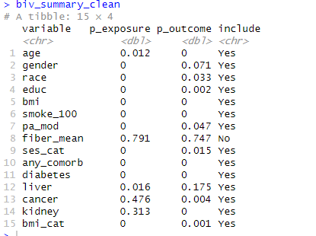

  - VIF check for multicollinearity
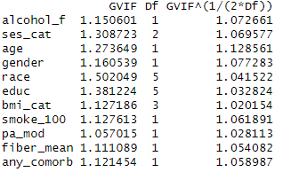

  - Model results
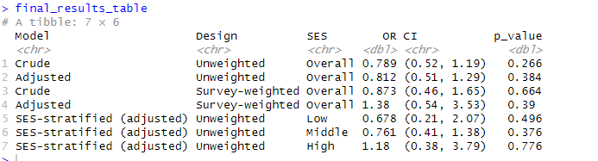

  - Result of a causal machine learning
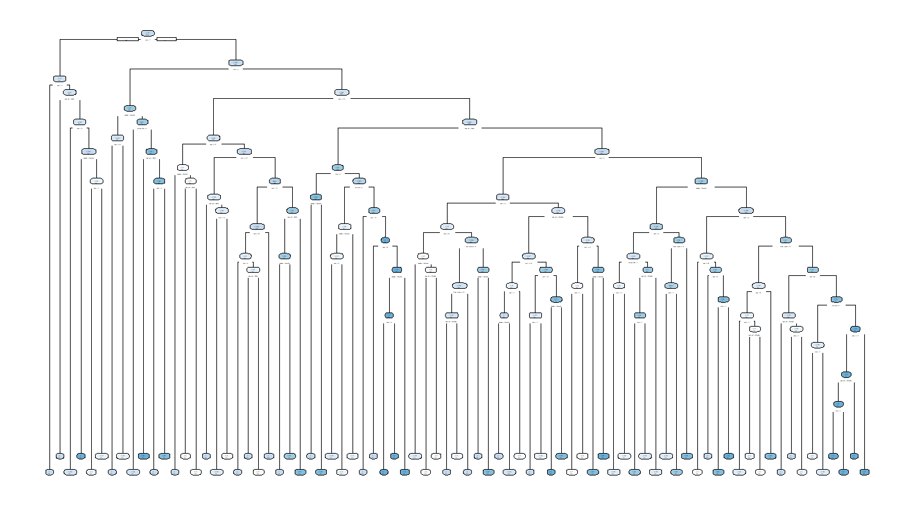
Result explanation

